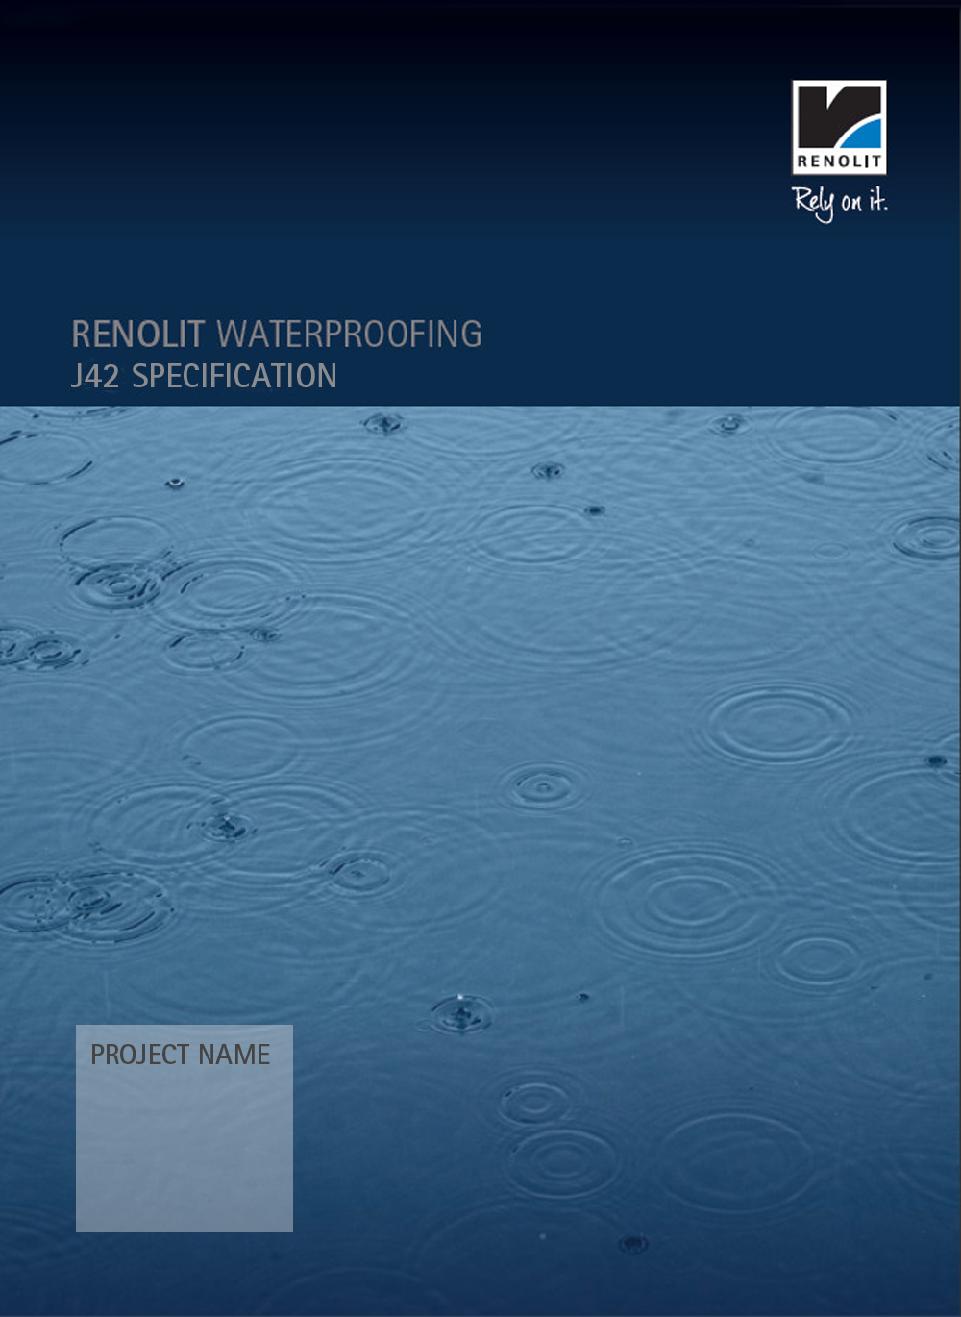

RENOLIT ALKORPLAN L
Generic

ALKORPLAN L

Generic

To be read with Preliminaries/ General Conditions.

The details contained within this proposal are based on information available at the time of writing. It covers the installation of RENOLIT ALKORPLAN materials and the preparation work necessary to provide a suitable substrate.
RENOLIT Cramlington Ltd. can not be held responsible for unknown site conditions or for the performance of materials within the system other than those manufactured by RENOLIT Cramlington Ltd.

A detailed method of work statement and programme of works should be agreed with the RENOLIT Cramlington Ltd. approved contractor prior to the commencement of the works.

All RENOLIT ALKORPLAN membranes referenced in this specification have a life expectancy certified by the British Board of Agrément in excess of thirty five years (Certificate 10/4808 dated 11th March 2013).

The Project Manager (PM) referred to in the following is Architects Name or their designated agent.

ROOF COVERING CONTRACTOR

The work is to be carried out by a RENOLIT Cramlington Ltd. Approved and Registered Contractor.

The RENOLIT Cramlington Ltd. Designation is Name (Telephone: Mobile number E-mail: Address) and he lists the following companies:

J42 SINGLE LAYER POLYMERIC SHEET ROOF COVERINGS

TYPES OF COVERING

110 WARM ROOF COVERING
- Substrate: Galvanised steel 0.7, 0.9, 1.2mm to BS EN 10147:2000.
Aluminium 0.9mm to BS EN 485-2: 1995 AA3004.
18mm Plywood certificated to conform to BS5268 Part 2
and to BS EN 636.
18mm OSB manufactured to BS EN300 1997, grade OSB/3.
25mm Timber boarding.
Concrete slab cast nominally flat.
Woodwool cement slab to conform to BS EN 13168, minimum 50mm
thick.
- Preparation: Clean off or any special requirements specific to a particular project.
- Roof covering system: RENOLIT ALKORPLAN L. Loose laid.
- Manufacturer: RENOLIT Cramlington Ltd., Station Road, Cramlington, Northumberland. NE23 8AQ. Tel: 01670 718283 Fax: 01670 590096
- Vapour control layer: RENOLIT ALKORPLUS SK self adhesive VCL, 81002
- Insulation: Insulation Manufacturers Name
- Waterproof membrane: RENOLIT ALKORPLAN L 35177 015.
Width: 2050mm.
Thickness: 1.5mm.
Colour: Light Grey Ref: 71004.
Seam Sealer: All welded laps to be sealed with RENOLIT ALKORPLUS seam sealer
81038 004
- Upper protective layer (welded at its laps and loose laid): RENOLIT ALKORPLAN
35121 protection layer.
- Surface Finish: HP Paves to provide a minimum 80KG/m2 dead load, preferably
120Kg.
- Accessories: Pre-formed RENOLIT ALKORPLAN metal profiles reference 81171.
RENOLIT ALKORPLUS pre-formed membrane corners reference 81060 014
(internal) 81061 014 (external). RENOLIT ALKORSEAL 81150 silicone sealant, for interfaces between RENOLIT ALKORPLAN and other surfaces, plus system accessories recommended by RENOLIT Cramlington Ltd,.

PERFORMANCE

201 MANUFACTURER’S WARRANTY
- In order to comply with the RENOLIT Warranty, the work is be carried out by a Registered Contractor approved by RENOLIT Cramlington Ltd. The warranty will be for a period determined by the PM. Maximum ? years.

210 ROOF PERFORMANCE
- Roof covering: Secure, free draining and weathertight.

220 VAPOUR CONTROL.
Refer to Condensation Risk Analysis Calculations provided by the proposed insulation manufacturer.
- Interstitial condensation risk of roof: Determine as recommended in BS 6229. Modify calculation method to conform to BS 5250.
- Basic design data:
- Outdoor notional psychrometric conditions, winter:
Temperature: -5°C.
Relative humidity: 90%.
Vapour pressure: 0.36 kPa.
Duration: 60 days.
- Outdoor notional psychrometric conditions, summer:
Temperature: 18°C.
Relative humidity: 65%.
Vapour pressure: 1.34 kPa.
Duration: 60 days.
- Indoor notional psychrometric conditions:
Temperature: PM to confirm.
Relative humidity: PM to confirm.
Vapour pressure: PM to confirm.
- Winter interstitial condensate:
- Calculated amount (maximum): 0.35 kg/m².
- Calculated annual net retention: Nil.
- Vapour control layer: If calculated amounts of condensate exceed allowed amounts, provide a suitable membrane or sealed deck so that damage and nuisance from interstitial condensation do not occur.

230 INSULATION
- Requirement: Determine type and thickness of insulation and integral or separate overlay to satisfy the following criteria:
- Thermal transmittance of the roof (maximum): PM to confirm
- Compressive strength of insulation (minimum) at 10% compression: 0.06N/mm²
- Finished surface: Suitably even, stable and robust to receive roof covering.
- Insulation compliance: To a relevant British Standard, or Agrément certified.

240 ATTACHMENT OF RENOLIT ALKORPLAN:
- Requirement: Determine methods of attachment to resist wind loads. Provide for relative movement of materials and effects of vapour pressure. Do not reduce performance of vapour control layer.
- Wind loads: Calculate to BS 6399-2, Standard Method.
- Site Postcode: PM to confirm
- Building Dimensions: PM to confirm.
- Basic wind speed (Vb): PM to confirm.
- Altitude factor (Sa): PM to confirm.
- Direction factor (Sd): PM to confirm.
- Seasonal factor (Ss): 1.
- Probability factor (Sp): 1.
- Terrain and building factor (Sb): PM to confirm.
- Size effect factor (Ca): 1.
- External pressure coefficients (Cpe): PM to confirm.
- Internal pressure coefficients (Cpi): PM to confirm.
- Parapet (if any) height: PM to confirm.
- Urban Shelter, Angle between perpendicular to the longitudinal axis and North: PM to confirm.

PRODUCTS

330 TIMBER TRIMS, ETC
- Quality: Planed. Free from wane, pitch pockets, decay and insect attack except ambrosia beetle damage.
- Moisture content at time of covering (maximum): 22%.
- Preservative treatment: Only aqueous, salt-based preservatives allowed when timber is in direct contact with RENOLIT ALKORPLAN membrane.

340 PREFORMED SLEEVES, ETC
- Type: Flexible PVC and PVC laminated metal.
- Manufacturer: RENOLIT Cramlington Ltd.
- Product reference: Various.
- Colour: To match membrane.
- Size: To suit RENOLIT ALKORPLAN Design Details.

345 PERIMETER TRIMS
- Type: 0.6mm galvanised steel with 0.8mm unreinforced PVC membrane laminate.
- Manufacturer: RENOLIT Cramlington Ltd.,
- Product reference: RENOLIT ALKORPLAN 81171 006.
- Colour: Lead Grey Ref: 73320
- Size: 3.000 x 1.000 metre.

355 MECHANICAL FASTENERS, WASHERS, PRESSURE PLATES, ETC
For fixing perimeter trims etc.
- Type: In accordance with the current edition of the British Board of Agrément MOAT 55 UEAtc Supplementary Guide for the assessment of mechanically fastened roof waterproofing for Class 2 fasteners or a suitable alternative recommended in writing by RENOLIT Cramlington Ltd.
- Manufacturer: To the Approval of RENOLIT Cramlington Ltd.
- Product reference: Plastic washer tubes and fasteners to the approval of
RENOLIT Cramlington Ltd.

370 COVER STRIPS TO JOINTS IN RIGID BOARD SUBSTRATES
- Bitumen membrane: To BS 747, type 5U.
- Manufacturer: To Approval
- Width: 150 mm.

375 MINOR MOVEMENT JOINTS IN SUBSTRATES
- Manufacturer: Submit proposals if required.
- Product reference: To Approval.

396 VAPOUR CONTROL LAYER
- Type: RENOLIT ALKORPLUS SK Self Adhesive.
- Manufacturer: RENOLIT Cramlington Ltd.
- Product reference: 81002
- Thickness: 1.20mm.
- Vapour resistance: Conforms to DIN 18530/5.
- Lay in accordance with manufacturer’s instructions.

421 RIGID URETHANE FOAM WARM ROOF INSULATION
- Type: Description
- Manufacturer: Address and contact details
- Product reference: Type
- Density: 32kg/m³ minimum.
- Thickness: ?mm to achieve a U-value of ? W/m2 K
- Facing: Foil face to both sides.
- Fixing: Mechanical

465 PRECAST CONCRETE PAVING SLABS
- Standard: To BS 7263-1, hydraulically pressed.
- Manufacturer: PM to confirm.
Manufacturer to confirm that the paving slabs are suitable for placing upon supports.
- Product reference: PM to confirm.
- Colour/ Finish: PM to confirm.
- Size: PM to confirm.

467 SUPPORT SYSTEM FOR PRECAST CONCRETE PAVING SLABS
- Manufacturer: Instar UK Limited, Tregeseck House, Whites Hill, Sulhamstead,
Reading. RG7 4EL Tel: 0118 9832405
- Product reference: To Approval.
- Colour/ Finish: To Approval.
- Size: To Approval.
- Accessories: To Approval

480 PIPE COLLARS
- Manufacturer: Contractor Fabricated
- Size: To suit Design Details.

EXECUTION GENERALLY

510 ADVERSE WEATHER
- General: Do not lay membrane at temperatures below 5°C or in wet or damp conditions unless effective temporary cover is provided over working area.
- Unfinished areas of roof: Keep dry and protect edges of laid membrane from wind action.

520 INCOMPLETE WORK
- End of working day: Provide temporary seal to prevent water infiltration.
- On resumption of work: Cut away tail of membrane from completed area and remove from roof.

550 CONTROL SAMPLES
- Type of covering: RENOLIT ALKORPLAN.
- Sample area (minimum): 20m².
- Location: To be agreed with PM.
- Approval of appearance: Obtain before proceeding.

SUBSTRATES/ VAPOUR CONTROL LAYERS/ WARM ROOF INSULATION

610 SUITABILITY OF SUBSTRATE
- Surfaces to be covered: Firmly fixed, clean, dry, smooth, free from frost, contaminants, voids and protrusions.
- Preliminary work: Complete, including:
- Grading to correct falls.
- Formation of upstands, kerbs, box gutters, sumps, grooves, chases and expansion joints.
- Fixing of battens, fillets and anchoring plugs/ strips.
- Moisture content and stability of substrate: Must not impair integrity of roof.

640 FIXING TIMBER TRIMS
- Fasteners: Sherardized steel screws.
- Fixing centres (maximum): 600mm.

660 JOINTS IN RIGID BOARD SUBSTRATES
- Cover strip: Lay centrally over substrate joints before laying vapour control layers or coverings. Adhere to substrate with bonding compound along edges only.

670 LAYING VAPOUR CONTROL LAYER
- Laying: Sheets flat and smooth.
- Side and head laps: 50 and 75 mm respectively.
- Upstands, kerbs and other penetrations: Enclose edges of insulation. Fully seal at abutment by bonding or taping

680 LAYING WARM ROOF INSULATION
- Setting out:
- Long edges: Fully supported and running at right angles to metal deck profile.
- End edges: Adequately supported.
- Joints: Butted together.
- End joints: Staggered.
- In accordance with board manufacturer’s recommendations.
- Completion: Boards must be in good condition, well fitting and firmly fixed.

WATERPROOF COVERINGS/ ACCESSORIES

730 WELDED JOINTING
- Laying: Loose lay, do not wrinkle or stretch.
- Side and end joints:
- Laps (minimum): 100mm.
- Preparation: Clean and dry surfaces for full width of joint.
- Sealing: Weld together.
- Seam sealant: RENOLIT ALKORPLUS 81038 in colour to match membrane.
- Condition at completion: Fully sealed, smooth, weatherproof and free draining.

760 PERIMETER OF MEMBRANE
- General: Secure membrane at roof edge conditions, changes of plane, curb flashings, upstands to roof lights, etc. with mechanical fasteners

750 TAPE JOINTING: ADHERED SYSTEM
- Transverse joints:
- Laps: Butt jointed.
- Preparation: Clean and dry surfaces for full width of joint. Below the joint a, 200mm wide, strip to remain free of adhesive.
- Sealing: Apply 50mm wide self adhesive aluminium tape to the joint and weld a 200mm wide detailing membrane.
- Do not wrinkle or stretch membrane.
- Seam sealant: Alkorplan 81038 in colour to match membrane.
- Condition of membrane at completion: Fully sealed, weatherproof and free draining.

765 PERIMETER DETAILS FOR THERMOPLASTIC MEMBRANES
- Upstands, edge trims, drips, kerbs, etc: Secure preformed metal sections to roof structure with mechanical fasteners.
- Roof membrane: Dress over perimeter profile. Overlap beyond fasteners by minimum 50mm.
- Sealing: Weld together.

780 ROOF PENETRATIONS THROUGH THERMOPLASTIC MEMBRANES
- Roof membrane: Cut around penetrations and secure to deck.
- Flanged sleeve:
- Type: Contractor fabricated.
- Installation: Dress over and around penetration.
- Roof membrane overlap to flange (minimum): 50 mm beyond fasteners.
- Sealing: Weld flange to roof membrane.
- Protection to top edge of sleeve: Flashing or weathering cravat.

790 RAINWATER OUTLETS
- Recess into the roof and firmly secure with no lip preventing the free flow of
water.
- Type(s) recommended for the purpose by membrane manufacturer.
RENOLIT ALKORPLUS 810880 series.

COMPLETION

910 INSPECTION
- Interim and final roof inspections: Submit roof covering manufacturer's reports.

920 ELECTRONIC ROOF INTEGRITY TEST
- Testing authority: The Approved Roofing Contractor.
- Timing of test: Prior to handover of roof at completion.
- Condition of roof prior to testing:
- Waterproof membrane complete to a stage where integrity can be tested.
- Surface: Clean.
- Test results and waterproof integrity certificate: Submit on completion of testing.

930 FLOOD TEST: Generally only in specific areas required by the PM.
- Condition of roof prior to testing:
- Waterproof membrane complete to a stage where integrity can be tested.
- Outlets: Externally cover and seal. Protect against damage from water pressure using temporary kerbs. Do not use plugs to seal outlets.
- Flood levels: Submit proposals. In no case higher than kerbs.
- Flood duration: 24 hours.
- Inspection: Regular, to detect leaks.
- Completion of test: Slowly drain roof. Do not overload or flood outlets.
- Test results: Submit.

940 COMPLETION
- Roof areas: Clean.
- Outlets: Clear.
- Work necessary to provide a weathertight finish: Complete.
- Storage of materials on finished surface: Not permitted.
- Completed membrane: Do not damage. Protect from traffic and adjacent or high level working.

